PRN : 2020BTECS00212
Assignment No-2
Software Engineering Tools Lab
(Module 2- Software Development Frameworks)
Due date-11/02/2022
.......................................................................

Question 1. List of Frameworks/IDEs/Softwares :
- Eclipse
- Android SDK
- Node.Js
- DotNet
- Ruby on Rails
- Anaconda
- Google colab
For every Frameworks/IDEs/Softwares given above provide the answers for below questions :
1. Original author
2. Developers
3. Initial release
4. Stable release
5. Preview release
6. Repository (with cloud support )
7. Written in (Languages)
8. Operating System support
9. Platform ,portability
10. Available in (Total languages)
11. List of languages supported
12. Type (Programming tool, integrated development environment etc.)
13. Website
14. Features
15. Size (in MB, GB etc.)
16. Privacy and Security
17. Type of software (Open source/License)
18. If License- Provide details.
19. Latest version
20. Cloud support (Yes/No)
21. Applicability
22. Drawbacks (if any)

Answer :
1. Eclipse :

1. Original author : IBM
2. Developers : Eclipse Foundation
3. Initial release : 1.0 / 7 November 2001; 20 years ago
4. Stable release : 4.22.0 / 8 December 2021 (2 months ago)
5. Preview release : 4.21 (2021-09 release)
6. Repository (with cloud support ) : git.eclipse.org/c/
7. Written in (Languages) : Java & C
8. Operating System support : Linux , macOS , Windows
9. Platform ,portability : Java SE , Standard Widget ToolKit , x86-64
10. Available in (Total languages) : 44 languages
11. List of languages supported : Albanian, Arabic, Basque, Bulgarian, Catalan, Chinese (simplified, traditional), Czech, Danish, Dutch, English (Australia, Canada), Estonian, Finnish, French, German, Greek, Hebrew, Hindi, Hungarian, Indonesian, Italian, Japanese, Klingon, Korean, Kurdish, Lithuanian, Malayalam, Mongolian, Myanmar, Nepali, Norwegian, Persian, Polish, Portuguese (Portugal, Brazil), Romanian, Russian, Serbian, Slovak, Slovenian, Spanish, Swedish, Thai, Turkish, Ukrainian, Vietnamese .
12. Type (Programming tool, integrated development environment etc.) : Computer Program , source code , editor , Compiler or Interpreter . IDE's : NetBeans & Eclipse .
13. Website : www.eclipse.org/eclipseide/
14. Features : It is a powerful tool and Integrated Development Environment (IDE) for the developers / programmers using Java, C and Python. It has a good and modern user interface. It is available to download and use for multiple operating systems. It is open source and free to download and use .
15. Size (in MB, GB etc.) : The Eclipse download requires about 182 MB of disk space; keep it on your machine, in case you need to re-install Eclipse. When installed, Eclipse requires about an additional 220 MB of disk space.
16. Privacy and Security : Any personal data you share with Us, We protect according to this Privacy policy. We protect the integrity of your personal information with appropriate technical and organizational measures, such as using encryption for transmission of certain forms of information, to help keep it secure, accurate, current, and complete.
17. Type of software (Open source/License) : Open Source and Eclipse Public License (EPL) is a free and open source software license most notably used for the Eclipse IDE and other projects by the Eclipse Foundation.
18. If License- Provide details : The Eclipse Public License (EPL) is a free and open source software license most notably used for the Eclipse IDE and other projects by the Eclipse Foundation. It replaces the Common Public License (CPL) and removes certain terms relating to litigations related to patents.
19. Latest version : Eclipse 4.15 (2020-03)
20. Cloud support (Yes/No) : The Eclipse Cloud DevTools Working Group provides a vendor-neutral ecosystem of open-source projects focused on defining, implementing and promoting best-in-class web and cloud-based development tools.
21. Applicability : Unless otherwise indicated, all Content made available by the Eclipse Foundation is provided to you under the terms and conditions of the Eclipse Public License Version 1.0 ("EPL").
22. Drawbacks (if any) : Eclipse has a tendency to run slower than NetBeans and other IDEs. There are many reasons for this, such as insufficient memory allocation.

2. Android SDK :

1. Original author : Android was created by the Open Handset Alliance, which is led by Google.
2. Developers : Android Studio
3. Initial release : October 2009; 12 years ago
4. Stable release : 26.1.1 / September 2017; 4 years ago
5. Preview release : Released to stable channel (no longer in preview)
6. Repository (with cloud support ) : Google Cloud blocks the ability to create nested virtual machines, so Android Studio runs, but you can't run an AVD using the emulator.
7. Written in (Languages) : Java
8. Operating System support : Cross platform
9. Platform ,portability : Android SDK , Titanium Mobile SDK .
10. Available in (Total languages) : English
11. List of languages supported : Java , Kotlin , C++ , C# , Python , HTML , CSS , JavaScript .
12. Type (Programming tool, integrated development environment etc.) : IDE , SDK .
13. Website : developer.android.com/sdk/index.html
14. Features : Android SDK tool is a very important component of Android SDK. This component of SDK has various development and debugging tools.
15. Size (in MB, GB etc.) : Android SDK (Software Development Kit) (about 5 GB) for developing and testing Android apps.
16. Privacy and Security : Android is also investing in reducing the scope of permissions so that apps only have access to the data they need for the features they provide. Security is a major part of any Android device. Android was created with openness in mind, and is conducive to the use of third-party applications and cloud-based services.
17. Type of software (Open source/License) : The Android Open Source Project maintains Android software, and develops new versions. Because it's open source, this software can be used for any purpose, including developing devices that aren't compatible with other devices based on the same source.
18. If License- Provide details : The majority of the Android platform and documentation is licensed under the Apache 2.0 license. While the project strives to adhere to the preferred license, there may be exceptions, such as for documentation (code comments) extracted from a source code module that is licensed under GPLv2 or other license.
19. Latest version : The latest version of the Android SDK Build tool is 30.0. 3.
20. Cloud support (Yes/No) : Yes
21. Applicability : Android Studio is an intelligent code editor capable of advanced code completion, refactoring, and code analysis. The powerful code editor helps you be a more productive Android app developer.
22. Drawbacks (if any) : System requirements are higher than other tools , It takes a lot of time to build an application .

3. Node.Js :

1. Original author : Ryan Dahl
2. Developers : OpenJS Foundation
3. Initial release : May 27, 2009; 12 years ago
4. Stable release : 17.4.0 / January 18, 2022; 21 days ago
5. Preview release : October,20,2020
6. Repository (with cloud support ) : github.com/nodejs/node
7. Written in (Languages) : C , C++ , JavaScript
8. Operating System support : z/OS , Linux , macOS , Windows , SmartOS etc .
9. Platform ,portability : openJS Foundation
10. Available in (Total languages) : 3
11. List of languages supported : Node.js applications can be written in CoffeeScript, Dart, TypeScript, ClojureScript and others.
12. Type (Programming tool, integrated development environment etc.) : Runtime Environment .
13. Website : nodejs.org
14. Features : Cross-platform compatibility , Facilitates quick deployment and microservice development , Scalable .
15. Size (in MB, GB etc.) : 10 GB
16. Privacy and Security : Node.js is a JavaScript runtime environment, meaning it has everything you need to execute a program written in JavaScript. Though quite secure by itself, you should still think of additional ways to secure your Node.js apps.
17. Type of software (Open source/License) : Open Source , MIT License
18. If License- Provide details : MIT License
19. Latest version : Latest LTS Version: 16.14.0 (includes npm 8.3.1).
20. Cloud support (Yes/No) : Node. js on Google Cloud integrates with Cloud Monitoring, Cloud Trace, Cloud Logging, and Error Reporting, allowing you to transparently instrument live production applications to diagnose performance bottlenecks and software bugs.
21. Applicability : As a node.js best practices, we should develop modular applications by dividing the whole codebase into modular components. In this way, we don’t have to share code with others (e.g. APIs, services, data access, test cases, etc.) This makes the process easier. So that it’s very easy to reason about it.
22. Drawbacks (if any) : Node.js doesn't provide scalability. One CPU is not going to be enough; the platform provides no ability to scale out to take advantage of the multiple cores commonly present in today's server-class hardware , Dealing with relational database is a pain if you are using Node.

4. DotNet :

1. Original author : WILLIAM PENBERTHY
2. Developers : Microsoft
3. Initial release : February 14, 2002; 19 years ago
4. Stable release : 4.8.0 Build 4115 / May 1, 2021; 9 months ago
5. Preview release : Microsoft issued .NET 6 Preview 4 and revealed that the final .NET 6 version will ship on November 9.
6. Repository (with cloud support ) : EventSourcing.NetCore is intended to describe the concept of Event Sourcing and its implementation in the .NET 5 sample application.
7. Written in (Languages) : C# , F# , Visual Basic
8. Operating System support : Windows 98 or Windows NT 4.0
9. Platform ,portability : x86-64 , IA-32 , ARM
10. Available in (Total languages) : More than 60
11. List of languages supported : C#.NET , VB.NET , C++.NET , J#.NET , F#.NET JSCRIPT.NET , WINDOWS POWERSHELL , IRON RUBY , IRON PYTHON , C OMEG , ASML(Abstract State Machine Language) etc .
12. Type (Programming tool, integrated development environment etc.) : Software framework .
13. Website : dotnet.microsoft.com
14. Features : High Performance , Cross-Platform and Container Support , Security.
15. Size (in MB, GB etc.) : Requires 1 GB of RAM (1.5 GB if running on a virtual machine)
16. Privacy and Security : The common language runtime and .NET provide many useful classes and services that enable developers to write secure code, use cryptography, and implement role-based security.
17. Type of software (Open source/License) : Open Source , MIT License
18. If License- Provide details : MIT License
19. Latest version : 4.8.0 Build 4115 / May 1, 2021
20. Cloud support (Yes/No) : NET enables you to build fast, modern, and scalable cloud applications on all major cloud platforms. If you haven't yet decided on a cloud, we recommend Azure. Azure is the best cloud for .
21. Applicability : .NET platform and Microsoft technologies in general, a new version was consistently launched about every 6 months, introducing new features, improvements, and changes that had the purpose of meeting the newer requirements and trends on the market.
22. Drawbacks (if any) : Object-Relational Support Issues , It makes the object-relational programming (OOP) of .NET is something called the Entity Framework. There have been concerns regarding the flexibility of this framework with regard to new database designs in that it may not support the emerging ones.

5. Ruby on Rails :

1. Original author : David Heinemeier Hansson
2. Developers : BairesDev , Visuality , Rubyroid Labs etc .
3. Initial release : August 2004; 17 years ago
4. Stable release : 7.0.1 / 6 January 2022; 34 days ago
5. Preview release : Behold, behold, Rails 2.0 is almost here. But before we can slap on the final stamp, we’re going to pass through a couple of trial release phases. The first is this preview release, which allows you to sample the goodies in their almost finished state.
6. Repository (with cloud support ) : github.com/rails/rails
7. Written in (Languages) : Ruby
8. Operating System support : Mac , OSX or Linux .
9. Platform ,portability : server-side web application development platform.
10. Available in (Total languages) : Django in Python; Catalyst in Perl; Laravel, CakePHP and Yii in PHP; Grails in Groovy; Phoenix in Elixir; Play in Scala; and Sails.js in Node.js.
11. List of languages supported : Django in Python; Catalyst in Perl; Laravel, CakePHP and Yii in PHP; Grails in Groovy; Phoenix in Elixir; Play in Scala; and Sails.js in Node.js.
12. Type (Programming tool, integrated development environment etc.) : RubyMine IDE , Atom Editor , VIM Editor , Sublime Text , Aptana Studio , Emacs , Cloud9 , NetBeans.
13. Website : rubyonrails.org
14. Features : Ruby on Rails, or Rails, is a server-side web application framework written in Ruby under the MIT License. Rails is a model–view–controller (MVC) framework, providing default structures for a database, a web service, and web pages.
15. Size (in MB, GB etc.) : 57.8 MB
16. Privacy and Security : Web application frameworks are made to help developers build web applications. Some of them also help you with securing the web application. In fact one framework is not more secure than another: If you use it correctly, you will be able to build secure apps with many frameworks. Ruby on Rails has some clever helper methods .
17. Type of software (Open source/License) : Web application framework
18. If License- Provide details : MIT License
19. Latest version : 7.0.1 / 6 January 2022
20. Cloud support (Yes/No) : It's easy to get started developing Ruby on Rails apps that run on Google Cloud. Because the apps you create run on the same infrastructure that powers all of Google's products, you can be confident that they can scale to serve all of your users, whether there are a few or millions of them.
21. Applicability : Hospitality Service , Project Management System , Online Music Distribution , Slide Hosting Service .
22. Drawbacks (if any) : RoR is an opinionated framework with a lot of hard dependencies and modules included out of the box.

6. Anaconda :

1. Original author : Peter Wang and Travis Oliphant
2. Developers : Anaconda, Inc. (previously Continuum Analytics)
3. Initial release : Anaconda 2021.11 (Nov 17, 2021)
4. Stable release : 2021.11 / 17 November 2021; 2 months ago
5. Preview release : 0.8.0 /17 July 2012; 9 years ago
6. Repository (with cloud support ) : The Anaconda client command line interface (CLI) is used in a Terminal window to build and upload packages, connect to and manage your Anaconda Repository account from a Terminal window, upload packages you have created, and generate access tokens to manage access to private packages.
7. Written in (Languages) : Python
8. Operating System support : Windows , macOS , Linux
9. Platform ,portability : It is available for Windows, macOS and Linux. The following applications are available by default in Navigator: JupyterLab.
10. Available in (Total languages) : Python and R programming languages for scientific computing (data science, machine learning applications, large-scale data processing, predictive analytics, etc.)
11. List of languages supported : Python and R programming languages for scientific computing (data science, machine learning applications, large-scale data processing, predictive analytics, etc.)
12. Type (Programming tool, integrated development environment etc.) : Programming language , machine learning , data science .
13. Website : anaconda.com
14. Features : It is free and open-source. , It has more than 1500 Python/R data science packages. , Anaconda simplifies package management and deployment.
15. Size (in MB, GB etc.) : Recommended minimum of 100 GB, or 300 GB if you are planning to mirror both Anaconda Repository, which is approximately 90 GB, and the PyPI repository, which is approximately 100 GB, or at least 1 TB for an air gapped environment.
16. Privacy and Security : Anaconda has adopted and complies with the EU-U.S. and Swiss-U.S. Privacy Shield Frameworks (“Privacy Shield”) as set forth by the U.S. Department of Commerce regarding the collection, use, and retention of personal data transferred from the European Union to the United States .
17. Type of software (Open source/License) : Yes it is Open Source .
18. If License- Provide details : Freemium
19. Latest version : Anaconda Individual Edition 2021.11 includes a new release of Anaconda Navigator - version 2.1. 1.
20. Cloud support (Yes/No) : Anaconda for cluster management can launch and bootstrap clusters on a variety of cloud services. We currently support Amazon EC2. Other providers such as Microsoft Azure, Rackspace, Google Cloud Platform, and others are on our roadmap.
21. Applicability : Anaconda is a distribution of the Python and R programming languages for scientific computing (data science, machine learning applications, large-scale data processing, predictive analytics, etc.), that aims to simplify package management and deployment.
22. Drawbacks (if any) : The application takes a lot of time to load the first time.
Sometimes, it stops working because it consumes more ram.

7. Google colab :

1. Original author : Fernando Perez and Brian Granger
2. Developers : Project Jupyter
3. Initial release : Google first started working with the Jupyter Development Team in 2014 to release an early version of the tool, , since then the tool has been constantly evolving.
4. Stable release : Currently, access to Colab is managed by services without individual controls. Later in 2021, the individual ON/OFF control for Colab will be available and control access to Colab.
5. Preview release : It was first publicly released in early 2018.
6. Repository (with cloud support ) : Colab notebooks allow you to combine executable code and rich text in a single document, along with images, HTML, LaTeX and more. When you create your own Colab notebooks, they are stored in your Google Drive account.
7. Written in (Languages) : three core programming languages supported by Jupyter, which are Julia, Python and R, and also a homage to Galileo's notebooks recording the discovery of the moons of Jupiter.
8. Operating System support : Colab is running Python 3.7, whereas you will run Python 3.8 on your machine through your Anaconda installation.
9. Platform ,portability : Google Colab! It's an incredible online browser-based platform that allows us to train our models on machines for free . Sounds too good to be true, but thanks to Google, we can now work with large datasets, build complex models, and even share our work seamlessly with others.
10. Available in (Total languages) : English
11. List of languages supported : Colab focuses on supporting Python and its ecosystem of third-party tools. We're aware that users are interested in support for other Jupyter kernels (eg R or Scala). We would like to support these, but don't yet have any ETA.
12. Type (Programming tool, integrated development environment etc.) : nonprofit organization .
13. Website : jupyter.org
14. Features : To support interactive data science and scientific computing across all programming languages .
15. Size (in MB, GB etc.) : While 32 GB of RAM is available in Colab Pro, Pro+ users have 52 GB available with the high-memory option. That is about 1.6 times as much as pro users and 3.25 times as much as free users.
16. Privacy and Security : Trusted by industry leaders and Fortune 500 companies, CoLab is built to the highest standards of security and data protection adopting a security-first approach to product development and infrastructure design, while giving end users the safest possible method to review critical data with their team and external partners.
17. Type of software (Open source/License) : Jupyter is the open source project on which Colab is based. Colab allows you to use and share Jupyter notebooks with others without having to download, install, or run anything.
18. If License- Provide details : Google Colab now also provides a paid platform called Google Colab Pro, priced at $9.99 a month. In this plan, you can get the Tesla T4 or Tesla P100 GPU, and an option of selecting an instance with a high RAM of around 27 GB.
19. Latest version : Python 3.8
20. Cloud support (Yes/No) : Google Colaboratory is a free online cloud-based Jupyter notebook environment that allows us to train our machine learning and deep learning models on CPUs, GPUs, and TPUs.
21. Applicability : Getting started with TensorFlow , Developing and training neural networks.
22. Drawbacks (if any) : overall usage limits as well as idle timeout periods, maximum VM lifetime, GPU types available, and other factors vary over time. Colab does not publish these limits, in part because they can (and sometimes do) vary quickly.

Question 2 .
Implement linear regression problem using Google colab (Perform preprocessing, training and testing) :
Dataset 1 -
https://www.kaggle.com/spittman1248/cdc-data-nutrition-physical-activity-obesity
Dataset 2-
https://archive.ics.uci.edu/ml/datasets/Air+Quality
Dataset 3-
https://archive.ics.uci.edu/ml/datasets/Appliances+energy+prediction
Dataset 4-
https://archive.ics.uci.edu/ml/datasets/Bike+Sharing+Dataset
Dataset 5- https://archive.ics.uci.edu/ml/datasets/Demand+Forecasting+for+a+store
Dataset 6-
https://archive.ics.uci.edu/ml/datasets/Hungarian+Chickenpox+Cases
Dataset 7-
https://archive.ics.uci.edu/ml/datasets/KDD+Cup+1998+Data
Dataset 8-
https://archive.ics.uci.edu/ml/datasets/Water+Quality+Prediction

Answer :

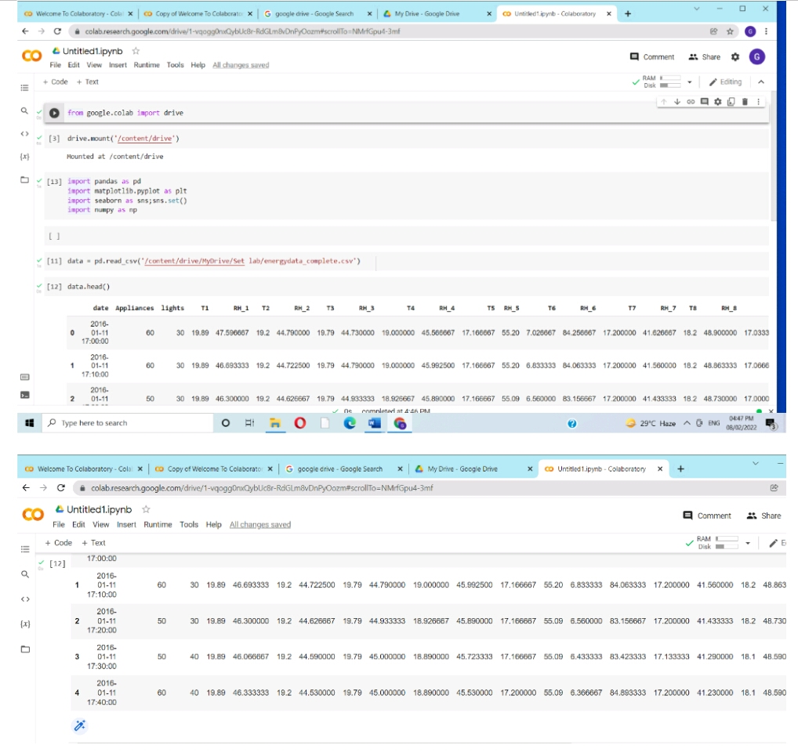
Dataset 3 :
https://archive.ics.uci.edu/ml/datasets/Appliances+energy+prediction
1. Loading Dataset :
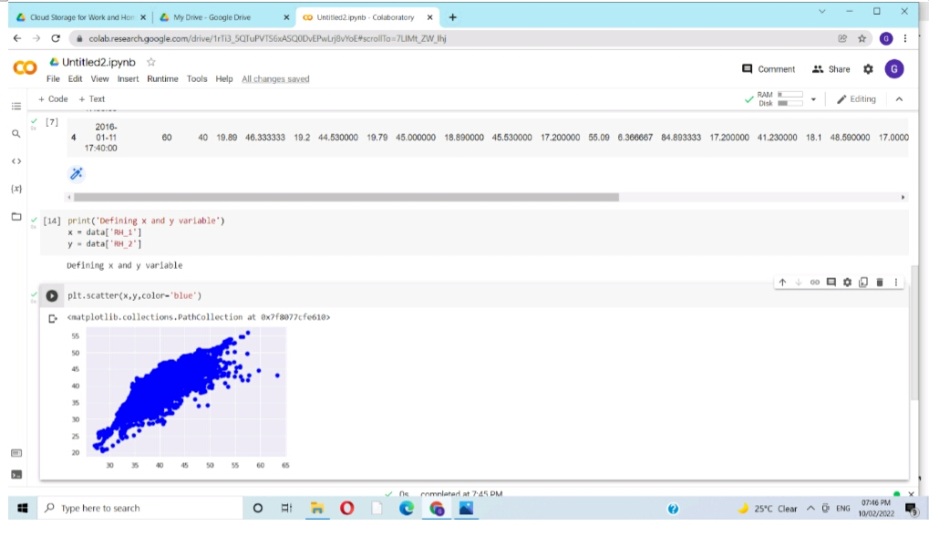
2. Preprocessing :

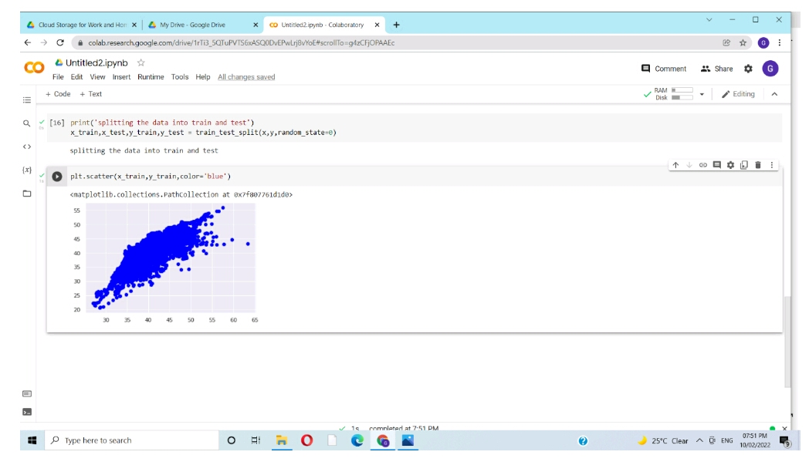

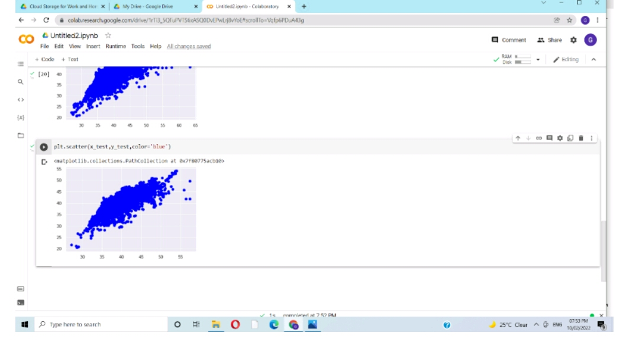
3.Training & Testing
..... END .....

